Практическая работа №12
Задание 1.
n = int(input())

numbers = list(range(1,n + 1, 2))

print(numbers)

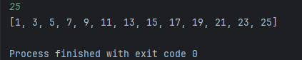

Задание 2.
prices = [1500, 500, 2000, 3500, 1000, 4500]

max_price = max(prices)
print(f"Самый дорогой товар: {max_price}")

min_price = min(prices)
print(f"Самый дешевый товар: {min_price}")

sum_price = sum(prices)
print(f"Общая стоимость товаров: {sum_price}")

print(f"Средняя цена товара: {sum_price/6}")

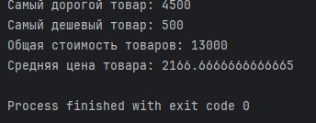

Задание 3.
users = ['Admin', 'Guest', 'User', 'Bot']

users[2] = "Moderator"
print(users)

users[-1] = "SuperAdmin"
print(users)

users.append("Newbie")
print(users)
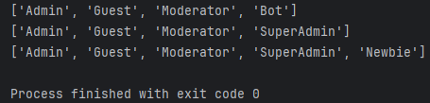

Задание 4.
marks = [5, 4, 3, 5, 2, 5, 4, 3, 5, 5]

five_count = 0
two_count = 0

for i in marks:
if i == 5:
five_count += 1
if i == 2:
two_count += 1

print(f"Количество пятерок: {five_count}")
print(f"Количество двоек: {two_count}")

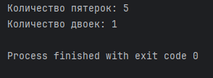

Задание 5.
data = [10, 20, 30, 40, 50, 60, 70, 80, 90, 100]

data2 = data[0:3:1]
data3 = data[7:11:1]
data4 = data[::-1]
data5 = data[1:11:2]

print(data2)
print(data3)
print(data4)
print(data5)

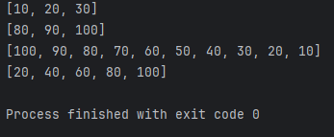

Задание 6.
word = str(input("Введите слово: "))

word = list(word)

word2 = word[::-1]

if word == word2:
print("Это палиндром")
else:
print("Не палиндром")

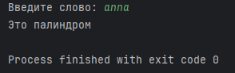
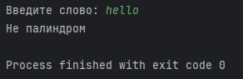

Задание 7.
numbers = [10, 20, 30, 40, 50]

number = int(input("Введите число: "))

for i in range(len(numbers)):
if numbers[i] == number:
break
if i == len(numbers) - 1:
print("Нет такого числа")

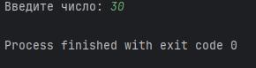
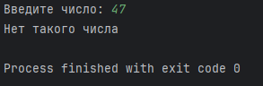

Задание 8.
numbers = [43, 4, 358, 7, 93]
print(numbers)

min_number = numbers.index(min(numbers))
numbers[0], numbers[min_number] = numbers[min_number], numbers[0]
print(numbers)

